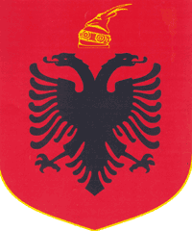
REPUBLIC OF ALBANIA
CENTRAL ELECTION COMMISSION

D E C I S I O N

ON APPROVAL OF THE PROCEDURE RULES "ON THE COMPOSITION, THE WAY OF ESTABLISHMENT, OPERATION AND PROCEDURES THAT ATTEND THE MEDIA MONITORING BOARD "

Central Election Commission in its meeting dated 23.03.2015, with the participation of:

Lefterije LUZI- Chair Woman
Denar BIBA- Deputy Chair
Edlira JORGAQI- Member
Gëzim VELESHNJA- Member
Hysen OSMANAJ- Member
Klement ZGURI- Member
Vera SHTJEFNI- Member

Based on the article 21, Point 1, Article 77, 80, 81, 83, 84, and 85 of Law nr.10019, dated 29.12.2008 "The Electoral Code of the Republic of Albania", amended, the Central Election Commission;

D E C I D E D :

Approval of the Rules of procedure "On the composition, the way of establishment and operation as well as the procedures followed by the Media Monitoring Board" attached to this Decision.

This decision comes into effect immediately.

Lefterije LUZI- Chair Woman
Denar BIBA- Deputy Chair
Edlira JORGAQI - Member
Gëzim VELESHNJA- Member
Hysen OSMANAJ- Member
Klement ZGURI- Member
Vera SHTJEFNI- Member

