REPUBLIC OF ALBANIA
CENTRAL ELCTION COMMISSION

D E C I S I O N

FOR THE APPROVAL OF THE MODEL AND QUANTITY OF BOXES AND ELECTION MATERIALS TO BE USED IN THE PARLIAMENTARY ELECTIONS OF 23 JUNE 2013

The Central Election Commission in its meeting dated 08.01.2013 with the participation of:

Lefterije LLESHI (LUZI)- Chairwoman
Denar BIBA- Vice Chairman
Albana SHTYLLA - Member
Hysen OSMANAJ- Member
Ilirjan MUHO- Member
Jani JANI- Member
Vera SHTJEFNI- Member

examined the issue with

OBJECT: for the approval of the model and quantity of boxes and elections materials to be used in the parliamentary elections of 23 June 2013.

LEGAL BASIS: Article 23, paragraph 1 / a, Article 99 paragraph 2 / a, of Law no. 10019 dated 29.12.2008 "The Electoral Code of the Republic of Albania" changed.:

The Central Election Commission after examining the submitted documentation and hearing the discussions of the participants;

NOTES:

Law "Election Code of the Republic of Albania", as amended, Article 99, paragraph 1 provides that the CEC sends the election materials divided into separate boxes for each polling station, to the CEAZs headquarters, no later than 3 days before the election. Pursuant to Law no. 9087, dated 19.06.2003 "The Electoral Code of the Republic of Albania", as amended, Article 93/1, item 1, which established for the first time using the box of election materials, which should be a safe box and closes with security codes, the CEC decided to adopt as a model of electoral materials box, the ballot box used in the 2003 local elections. This box model was used in the Assembly elections 2009 and partly in 2011 local elections. This is because with decision no. 99, dated 25.01.2011, the CEC decided adoption of new and safer specifications for the box of the election materials and the amount needed for the 2011 local elections. This decision was approved by the CEC based on the fact that the existing electoral materials boxes were extremely worn, a significant proportion of them was damaged and at the time of submission of the report from the administration of CEC, the amount of regular boxes and re-usable was 4.499, which amount was less than the total number of polling stations, not counting the required reserve amount.

After receiving the information and negotiating with the company which meets the conditions to ensure boxes according to the specifications laid down by the CEC, showed that the amount, timing of production and transport, it was more appropriate to commission the minimum quantity that the company can guaranty , 3000boxes for election materials. For this reason, with Decision no. 171, dated 16.03.2011, the CEC decided for a change in paragraph 2 of decision no. 99, dated 25.01.2011, reducing the number of boxes of election materials that should be provided for local elections in 3000 pieces, which were used for VC of the larger counties (Tiranë, Durres and Fier). Given the confidence that this election material should provide is very important , because in it are preserved all the documentation and election polling; And in conditions where the boxes of election materials used before the 2011 local elections give no guarantee for their safety, propose that the model of the ballot boxes and election materials be unified for all voting centers and the CEC will buy the required amount needed for this purpose

FOR THESE REASONS:

Central Election Commission under Article 23, paragraph 1 / a, Article 99 (2) / a, Law 10019 dated 29.12.2008 "The Electoral Code of the Republic of Albania",

D E C I D E D:

- In the parliamentary elections of Albania dated 08.01.2013 should be used the box and elections materials , approved by Decision no. 99, section 1, dated 25.01.2011 of the CEC.
- For the parliamentary elections of 23 June 2013 to use the amount of election materials boxes of 3000 pieces that are ready in CEC.
- The amount of new electoral material Boxes that will be purchased for the Parliamentary elections of 23 June 2013 is 3000 pieces.

- This decision shall enter into force immediately.

Lefterije LLESHI (LUZI)- Chairwoman
Denar BIBA- Vice Chairman
Albana SHTYLLA - Member
Hysen OSMANAJ- Member
Ilirjan MUHO- Member
Jani JANI- Member
Vera SHTJEFNI- Member

RELATION 1
Voting Box Model :
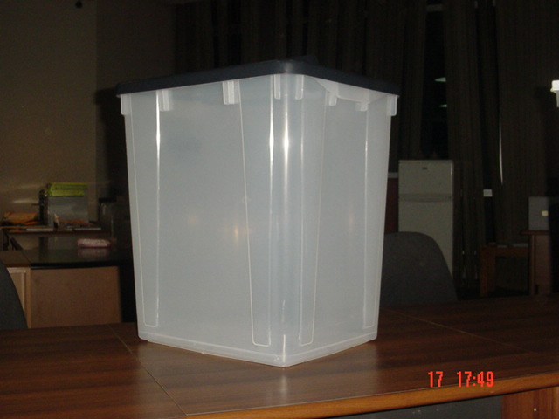
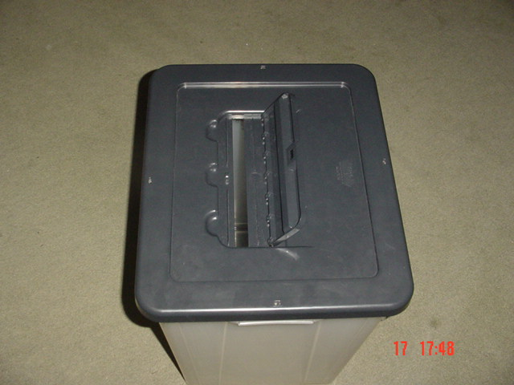
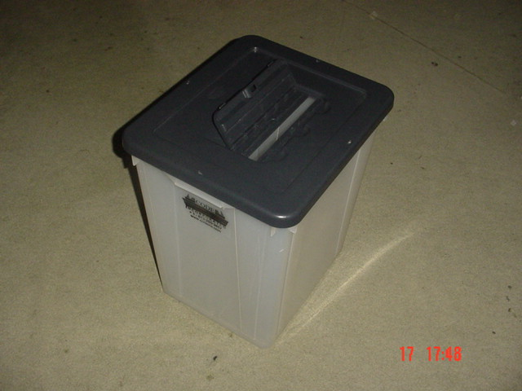

Specifications:
The capacity of the voting box:
83 liters (approximately ee equal to the capacity of 1,000 ballot A3 size) transparent,
plastic
Secure,
unflatening
reusable
closed box with 4 side metal codes and 1 code for the metal lid where jump ballot papers.

