REPUBLIC OF ALBANIA
CENTRAL ELCTION COMMISSION

D E C I S I O N

APPROVAL OF THE BALLOT BOX MODELS TO BE USED IN THE PARLAMENTARY ELCTIONS OF 23 JUNE 2013

The Central Election Commission in its meeting dated 08.01.2013 with the participation of:

Lefterije LLESHI (LUZI)- Chairwoman
Denar BIBA- Vice Chairman
Albana SHTYLLA - Member
Hysen OSMANAJ- Member
Ilirjan MUHO- Member
Jani JANI- Member
Vera SHTJEFNI- Member

Examined the issue with:

OBJECT: Approval of the ballot box model to be used in the Parliamentaryelections of 23 June 2013

LEGAL BASIS: Article 23, paragraph 1 / a, Article 99 2/ a, of Law no. 10019 dated 29.12.2008 "The Electoral Code of the Republic of Albania".
The Central Election Commission after examining the submitted documentation and hearing the discussions of the participants;
NOTES:

the law 10019 dated 29.12.2008, "The Electoral Code of the Republic of Albania", amended Article 99, paragraph 2, it determines that the CEC sends CEAZs headquarters ballot boxes for each voting center. Also, Law 10019 dated 29.12.2008 "The Electoral Code of the Republic of Albania", as amended, article 104, paragraph 1, defines that in parliamentary elections 1 (one) ballot box is placed at the Voting Center. With Decision no. 16, dated 26.02.2009, the CEC has set the pattern of the ballot box to be used in the Parliamentary elections of 28 June 2009. The box model was also used in the 2011 Local Elections . from the experience of these elections showed that the boxes of this model that were used appropriate, with sufficient capacity, maximum resistance and their volume was not a problem during transport. It is important to note that the CEC administers sufficient numbers of this model of the ballot box, which are in satisfactory physical condition to be reused in the electoral process .

FOR THESE REASONS:
Central Election Commission under Article 23, paragraph 1 / a, Article 99 2 / a, Law 10019 dated 29.12.2008 "The Electoral Code of the Republic of Albania" changed,\

D E C I D E D:

- In the Parliamentary elections of 23 June 2013 will be used a ballot box model, similar to what was used in the 2009 Parliamentary elections and the 2011 local elections, according to the relation 1, attached to this decision.
- This decision shall enter into force immediately.

Lefterije LLESHI (LUZI)- Chairwoman
Denar BIBA- Vice Chairman
Albana SHTYLLA - Member
Hysen OSMANAJ- Member
Ilirjan MUHO- Member
Jani JANI- Member
Vera SHTJEFNI- Member

Voting Box Model:

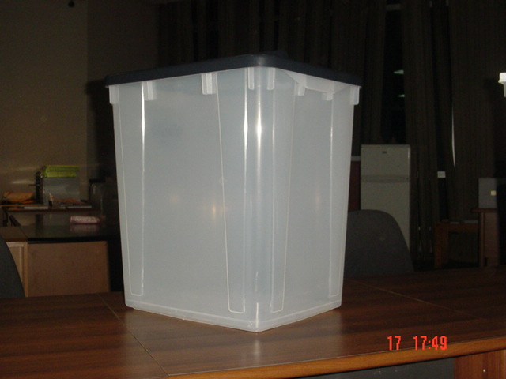
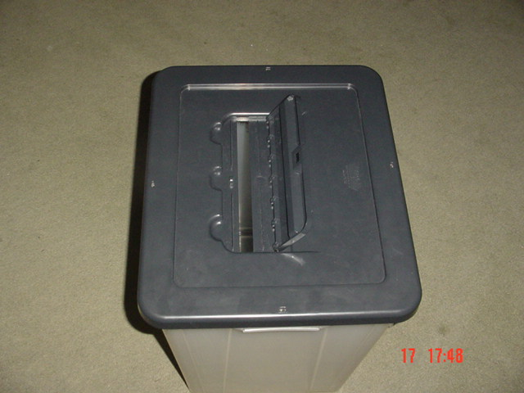
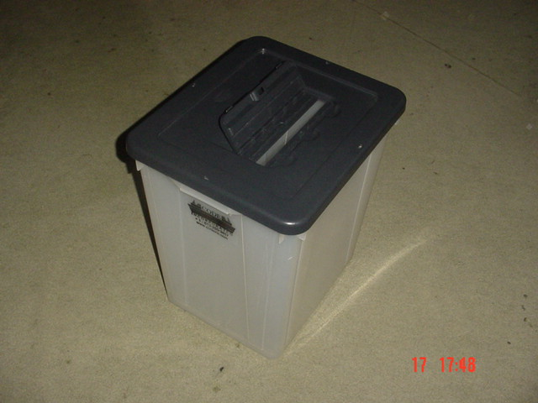

specifications:
The capacity of the ballot box:
83 liters (approximately ee equal to the capacity of 1,000 ballot A3 size)
specifications:
transparent,
plastic
sure,
papalosshme, reusable closed box with 4 side metal codes and 1 code for the metal lid where jump ballot papers.

